Week 2 sample programs

Design and implement Half adder, Full Adder, Half Subtractor, Full Subtractor using basic gates.(both hardware and software[pspice])

COMPONENTS REQUIRED:

Sl.no | Name of Component | No.’s
1 | IC7404 | 1
2 | IC 7408 | 2
3 | IC 7432 | 1
4 | Patch chords | 30
5 | Trainer kit | 1

HALF ADDER:

DESIGN (TRUTH TABLE):

i/p’s |  | o/p’s
A | B | Sum | Carry
0 | 0 | 0 | 0
0 | 1 | 1 | 0
1 | 0 | 1 | 0
1 | 1 | 0 | 1

SIMPLIFICATION:

Sum= A B + A B
Carry= A B

CIRCUIT:

A B

7404
7408
7432

Sum

Carry

FULL ADDER:

DESIGN (TRUTH TABLE):

i/p’s |  |  | o/p’s
A | B | Cin | Sum | Carry
0 | 0 | 0 | 0 | 0
0 | 1 | 0 | 1 | 0
0 | 0 | 1 | 1 | 0
0 | 1 | 1 | 0 | 1
1 | 0 | 0 | 1 | 0
1 | 1 | 0 | 0 | 1
1 | 0 | 1 | 0 | 1
1 | 1 | 1 | 1 | 1

SIMPLIFICATION:

Expression:- Sum = B Cin + A B Cin + A B Cin + A B Cin
Cin (A B +A B) + Cin(A B +A B)
Sum = Cin + Cin
Carry:- A B Cin + A B Cin + A B Cin + A B Cin
Cin(A B+ A B) + A B (Cin + Cin)
Cin+ A B

CIRCUIT DIAGRAM:

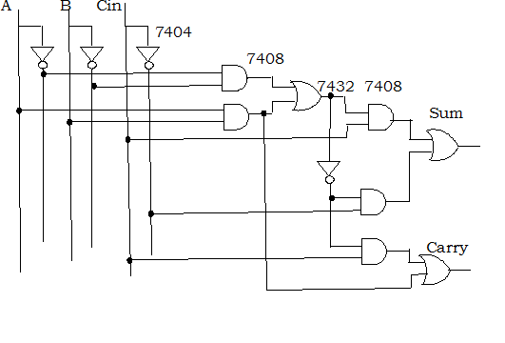

HALF SUBTRACTOR:

DESIGN (TRUTH TABLE):

i/p’s |  | o/p’s
A | B | Diff | Borrow
0 | 0 | 0 | 0
0 | 1 | 1 | 1
1 | 0 | 1 | 0
1 | 1 | 0 | 0

SIMPLIFICATION:

Diff= A B + A B

Borrow = A B

CIRCUIT:

A B

7404
7408
Borrow

Diff
7432

FULL SUBTRACTOR:

DESIGN (TRUTH TABLE):

i/p’s |  |  | o/p’s
A | B | Bin | Diff | Borrow
0 | 0 | 0 | 0 | 0
0 | 1 | 0 | 1 | 1
0 | 0 | 1 | 1 | 1
0 | 1 | 1 | 0 | 1
1 | 0 | 0 | 1 | 0
1 | 1 | 0 | 0 | 0
1 | 0 | 1 | 0 | 0
1 | 1 | 1 | 1 | 1

SIMPLIFICATION:

Difference :- A B Bin + A B Bin + A B Bin + A B Bin
= Bin(A B +A B) + Bin(A B +A B)

Borrow :- A B Bin + A B Bin + A B Bin + A B Bin
Bin(A B +A B) + A B (Bin + Bin)
= Bin + A B
Comparison b/w Full Adder and Full Subtractor

Sum = Diff = Cin + Cin
Borrow= Cin + A B

CIRCUIT:

